Statistics and Probability Course
Statistics
Statistics Basics
Statistics (Definition)
Types of Statistics
- Descriptive Statistics
- Inferential Statistics
Types of Statistical Studies
- Observational Study
- Designed Experiment
Sampling Terms
- Population
- Sample
- Sampling
- Sampling Unit
- Sampling Frame
- Census
- Sample Survey
- Parameter
- Statistic
- Representative Sample
- Homogeneity
- Heterogeneity

Sampling Techniques
Probability Sampling
- Simple Random Sampling
- Systematic Random Sampling
- Stratified Sampling
- Cluster Sampling
Non-Probability Sampling (not studied types)
- Convenience Sampling
- Judgement Sampling
- Quota Sampling
- Snowball Sampling
Variables and Data
Variable Terms
Variable
Qualitative Variable
Quantitative Variable
- Discrete Variable
- Continuous Variable
Study Variable Auxiliary Variable
Data & Data Types
Data
- Qualitative Data
- Quantitative Data
- Primary Data
- Secondary Data
Classifications of Data
- Time Series Data
- Cross-Sectional Data
- Panel Data
Presentation of Data
Quantitative Data
- Frequency Distribution Table
- Histogram
- Frequency Curve
- Frequency Polygon
Qualitative Data
- Simple Bar Chart
- Pie Chart
- Multiple Bar Chart (Cross Tabulation)
- Component Bar Chart
Descriptive Measure or Summary Measure
1. Measures of Central Tendency
- Arithmetic Mean
- Geometric Mean
- Harmonic Mean
- Median
- Mode

2. Measures of Variation or Dispersion
2.1 Absolute Measures
- Range
- Mean Deviation
- Standard Deviation
- Variance
2.2 Relative Measures
- Coefficient of Range
- Coefficient of Mean Deviation
- Coefficient of Variation
3. Measure of Skewness and kurtosis
- Right-Skewed
- Left-Skewed
- Zero Skewed
- Symmetric
4. Position Measures
- Quartile
- Decile
- Percentile

Probability Section
Probability
1. Things we need to know
- Uncertainty Due to Randomness
- Real and Hypothetical Population
- Deterministic and Unpredictable Results
- Event
- Sample Space
- Outcome
- Trial
- Null Event
- Sure Event
- Simple Event
- Compound Event
- Mutually Exclusive Events
- Exhaustive Events
- Equally Likely Events
- Permutation and Combinations
- Types of Probability
  - Objective (Classical Definition, Axiomatic Definition, Relative Frequency)
  - Subjective

2. Marginal and Joint Probability

3. Conditional Probability
4. Addition Law of Probability
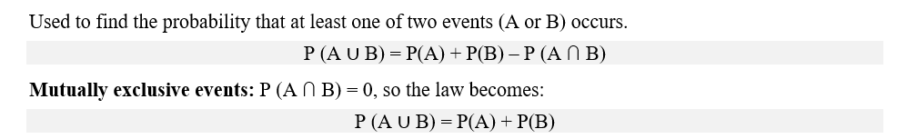
5. Multiplication Law of Probability
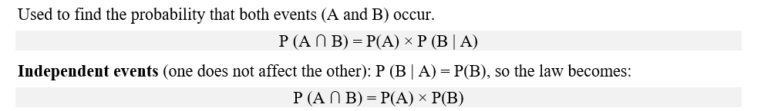
6. Bayes’ Theorem

